CENTRAL VIGILANCE COMMISSION (CVC), NEW DELHI
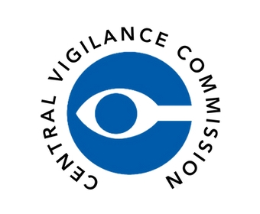
NATIONAL COUNCIL FOR TEACHER EDUCATION (NCTE), NEW DELHI

KALINGA UNIVERSITY, RAIPUR (C.G.)
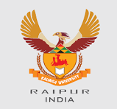
FACULTY OF EDUCATION
Theme: “सतर्कता: हमारी साझा जिम्मेदारी”
“Vigilance: Our Shared Responsibility – Education for Integrity and Transparency”

DAY 1 – Integrity First – National Pledge for Honesty
Date: 27 October 2025 | Time: 11:00 AM – 12:00 PM
Venue: WBFF 02 (Hybrid Mode)
Organized by: Faculty of Education & Faculty of Technology, Kalinga University, Raipur (C.G.)
Under the Guidance of: National Council for Teacher Education (NCTE) and Central Vigilance Commission (CVC India)
The Faculty of Education and Faculty of Technology jointly inaugurated Vigilance Awareness Week 2025 with the event “Integrity First – National Pledge for Honesty.” Prof. Dr. Shraddha Verma, Dean, Faculty of Education, addressed the gathering and administered the National Integrity Pledge, followed by all students and faculty members. Dr. V.C. Jha, Dean (In-Charge), Faculty of Technology, emphasized the importance of vigilance and ethical accountability in higher and technical education.
The event saw participation from over 100 students and faculty members. Banners and posters reflecting the national theme “Vigilance: Our Shared Responsibility – Education for Integrity and Transparency” were displayed, marking a vibrant start to the week-long observance.

Theme: “सतर्कता : हमारी साझा जिम्मेदारी”
“Vigilance: Our Shared Responsibility – Education for Integrity and Transparency”
Official Links:
• Central Vigilance Commission (CVC): https://www.cvc.gov.in
• National Council for Teacher Education (NCTE): https://www.ncte.gov.in
• Kalinga University: https://www.kalingauniversity.ac.in
#VigilanceAwarenessWeek2025 #IntegrityFirst #CVCIndia #NCTE #KalingaUniversity #EthicsInEducation #TransparencyMatters #SatarkBharat #OurSharedResponsibility

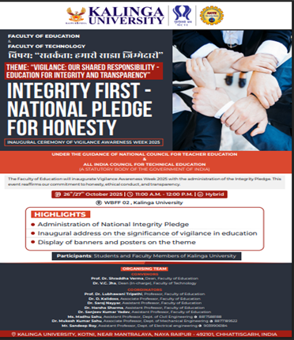 | 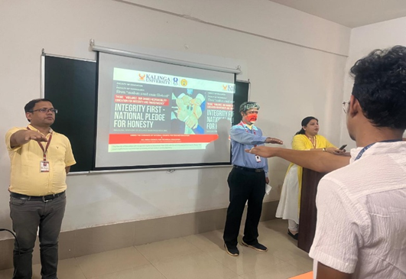 | 